**Kick Starter Data exercise conclusions**

1. Given the data set provided there are some basic trends that show themselves easily

* There is a huge spike in the amount of campaigns launched after 2014. This also corresponds to a reduction in the success rate of those campaigns. This is most likely a function of increased competition among the user base for funding because of the increased number of campaigns.

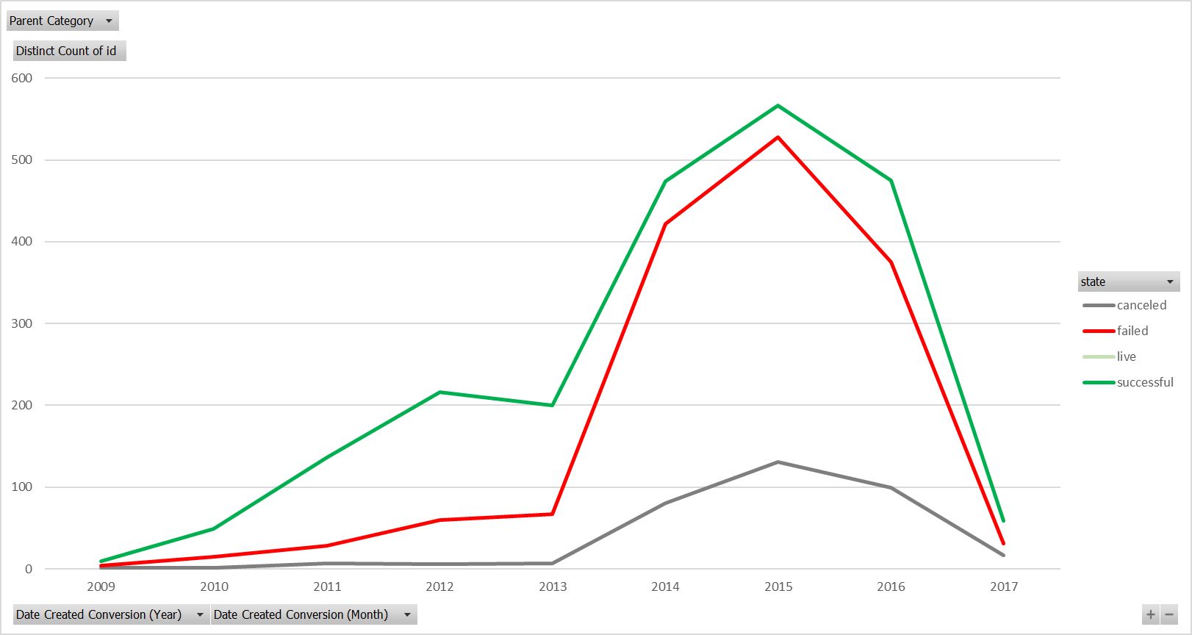

* Theater Film and Music projects are the most successful campaigns at getting fully funded

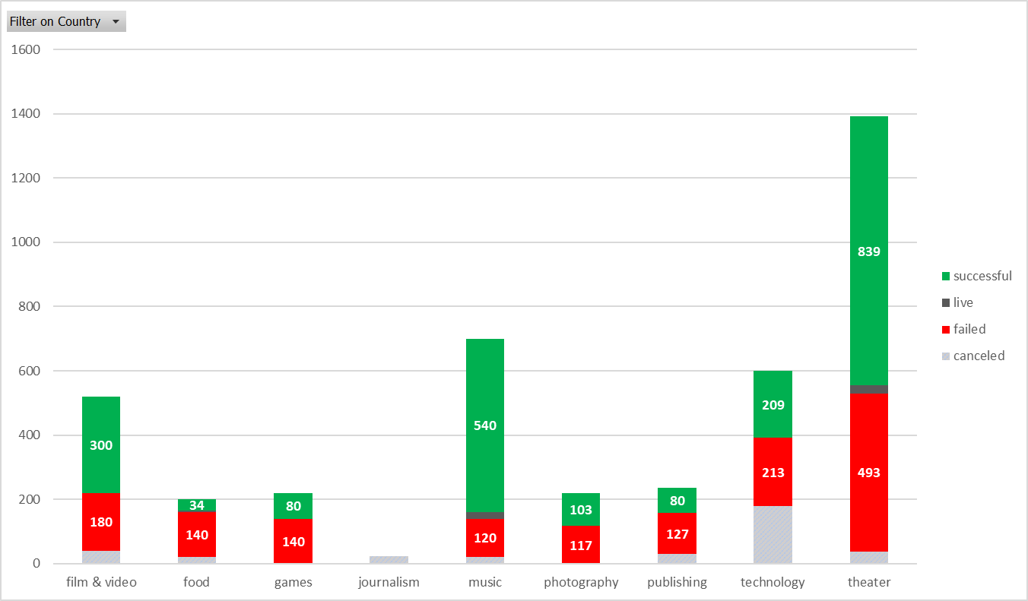

* Music projects are the most successful of all projects measuring by achieving funding targets



1. The primary piece of data I see as limiting conclusions in this data involves the engagement rate of the campaigns. Without knowing the user base of KickStarter relative to the dates the campaigns were launched it’s hard to distinguish how the success of individual campaigns stack up against the performance of Kick Starter as a platform. Traffic volume and click through rates would give a clearer picture of how closely the success of the platform’s success is distinguished relative to the structure of the individual campaigns.

The difference in currencies also affects our ability to truly distinguish how overall funding levels affect the success rate of the individual campaigns. Capturing the exchange rates at the time of campaign launch or conclusion would give us a more reliable measure of how overall funding levels affect the success of a given campaign in different countries. User engagement data would also be helpful in this regard as the platform may be performing at different levels in different countries.

Historical user data would also be helpful here, a user’s average donation could be useful in deciding which users to target a campaign towards.

1. I created graphs to relate the success rate of individual campaigns to the average donation. This data would not be as dependent on exchange rates as the data becomes self normalizing relative to currency values to an extent. This data could be used to target advertising based on the average donation size of a donor’s history in KickStarter.

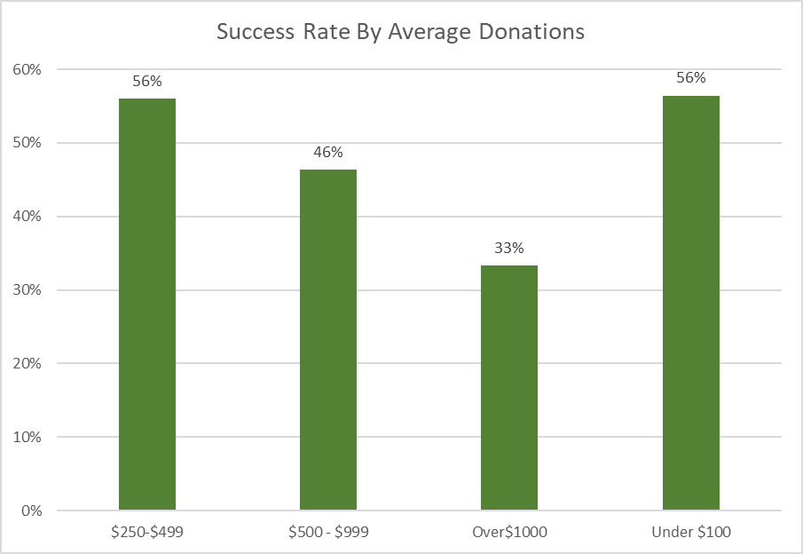

I also looked at this related to the start date of the campaigns to see if this trend is related to campaigns as well as Kickstarter’s evolution as a platform and it appear

